**Project Documentation:**

**Coffee Shop Sales Analysis and ARIMA Model Implementation**

**Table of Contents**

1. Introduction

2. Data Overview

3. Data Preprocessing

4. Exploratory Data Analysis

5. ARIMA Model Implementation

6. Power BI Dashboard

7. Conclusion

**Introduction**

This project involves the analysis of coffee shop sales data and the implementation of an ARIMA model to forecast future sales. Additionally, a Power BI dashboard is created to visualize various aspects of the sales data.

**Data Overview**

The dataset consists of transaction records with the following columns:

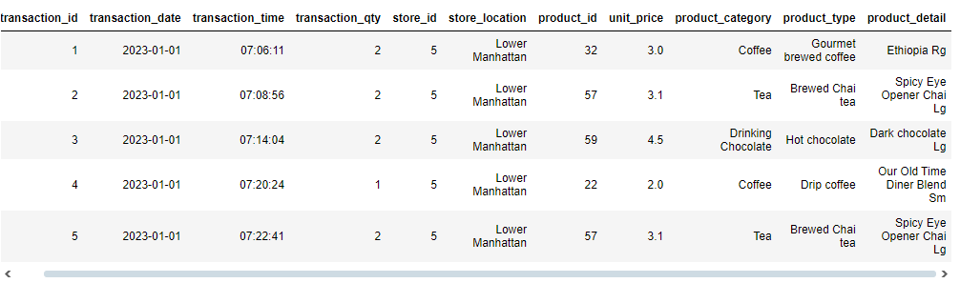

**Data Preprocessing**

1. **Load Data**: The data is loaded into a Pandas DataFrame for analysis.

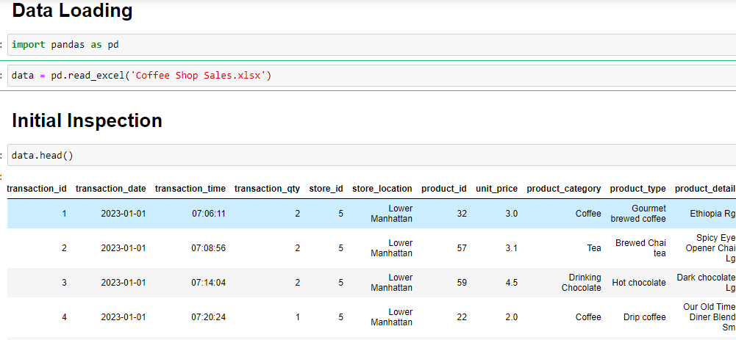

1. **Convert Data Types**:

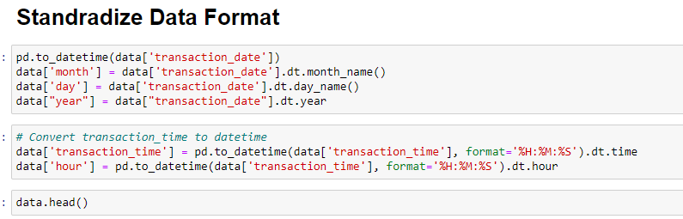

1. **Exploratory Data Analysis**
2. **Time Series Plot**: Visualize total transaction quantities over time.

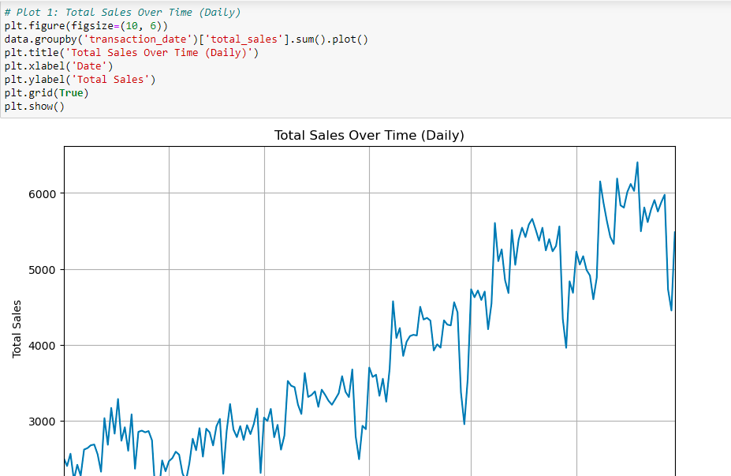

1. **Category**: Analyze sales distribution across different product categories using bar charts.

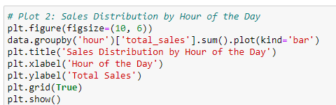

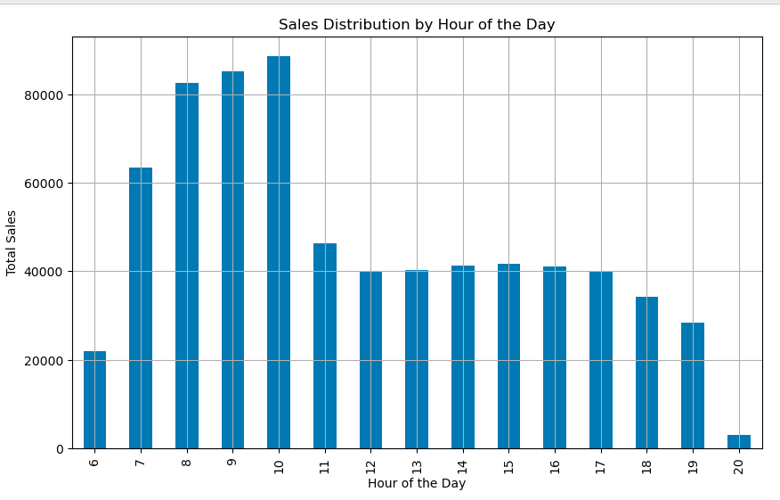

1. **Sales by Store Location**: Analyze sales distribution across different store locations using bar charts.

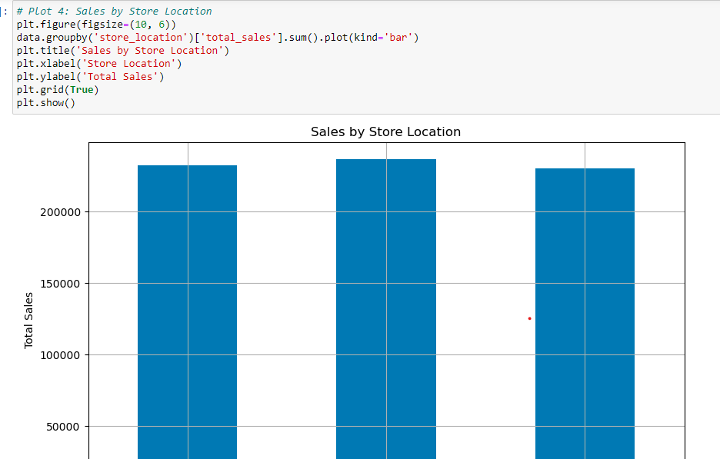

**ARIMA Model Implementation**

1. **Train-Test Split**: Split the data into training and test sets.

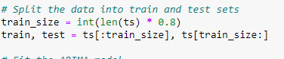

1. **Fit ARIMA Model**: Fit an ARIMA model to the training data.

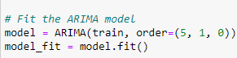

1. **Forecasting**: Make predictions on the test data.

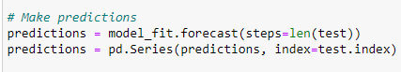

1. **Plot Results**: Visualize the actual vs. predicted values.

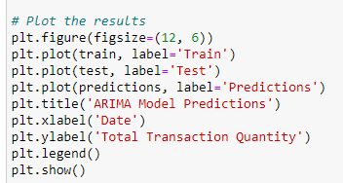

1. **Model Evaluation**: Evaluate the model's performance using Mean Squared Error (MSE).

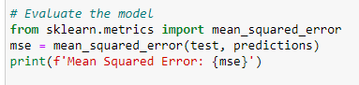

**Power BI Dashboard**

**Steps to Create the Dashboard**

1. **Load the Data**:
   * Open Power BI Desktop.
2. **Data Preparation**:
   * Inspect and clean your data if necessary in the Data view.
   * Ensure transaction_date is recognized as a date type.
3. **Create a Date Table** :
   * Go to the Modeling tab and click on New Table.
   * Create a Date table using the DAX formula:
   * Mark this table as a date table.
4. **Build Visuals**:
   * **Multi-RowCard:** Describe stores , products,customers etc.
   * **Total Sales by Product Category**: Use a Bar chart.
   * **Donate chart** : Describe product percentage.
   * **Tables.**
5. **Add Filters and Slicers**: Add slicers for product_category, store_location, or transaction_date.
6. **Customize and Format**: Add titles, labels, and format the visuals for clarity.

**Conclusion**

The analysis of coffee shop sales data revealed significant insights into sales trends over time, product performance, and store performance. The ARIMA model demonstrated the capability to forecast future sales with a reasonable level of accuracy, as evidenced by the Mean Squared Error metric.

To increase profit margins, focus on the following strategies:

1. Increase Promotion and Marketing:

Focus on promoting top products such as Barista Espresso, Brewed Chai tea, Hot chocolate, Gourmet brewed coffee, Brewed Black tea.

1. Optimize Pricing:

Evaluate and adjust the pricing strategy for high-impact products.

1. Inventory Management:

Ensure sufficient stock for high-demand products to avoid stockouts.

1. Customer Feedback:

Gather customer feedback on top products to further enhance their appeal.

1. Cross-Selling:

Bundle top products with other items to increase sales volume.

By implementing these strategies, you can effectively enhance profitability and maximize revenue growth.